We need to install plugins

* [CloudBees AWS Credentials](https://plugins.jenkins.io/aws-credentials/)
* [Amazon ECR](https://plugins.jenkins.io/amazon-ecr/)
* [Docker Pipeline](https://plugins.jenkins.io/docker-workflow/)

we need set up access key and secret key

**[]** login to j**enkins dashboard** and select **manage jenkins**

**[]** select system and scroll down in **Global properties** select **Environment variables [] add**

**[]** in **name** AWS_ACCESS_KEY_ID (we can give whatever,we use this name in pipeline)

**[]** in **value** AKIASM6XNBZOR5U2YE7 (I gave access key id what I created in aws )

**[]** add

**[]** in **name** AWS_SECRET_ACCESS_KEY (we can give whatever,we use this name in pipeline)

**[]** in **value** vK6JhW+lToii27wLUiDgnBLJnJzxSIayFD97Ect4 (I gave secret access key id what I created in aws )

**[]** save

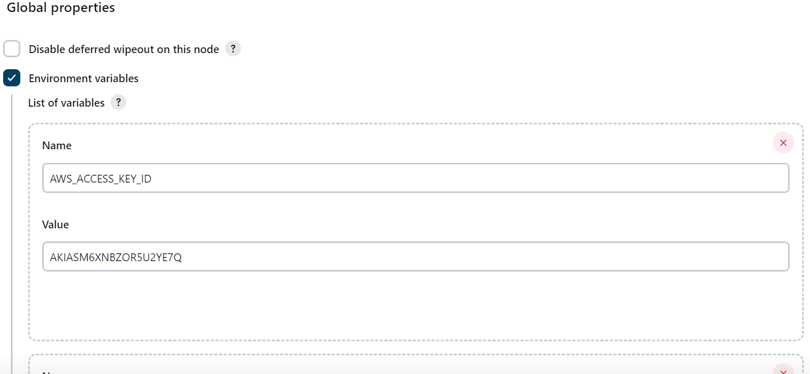

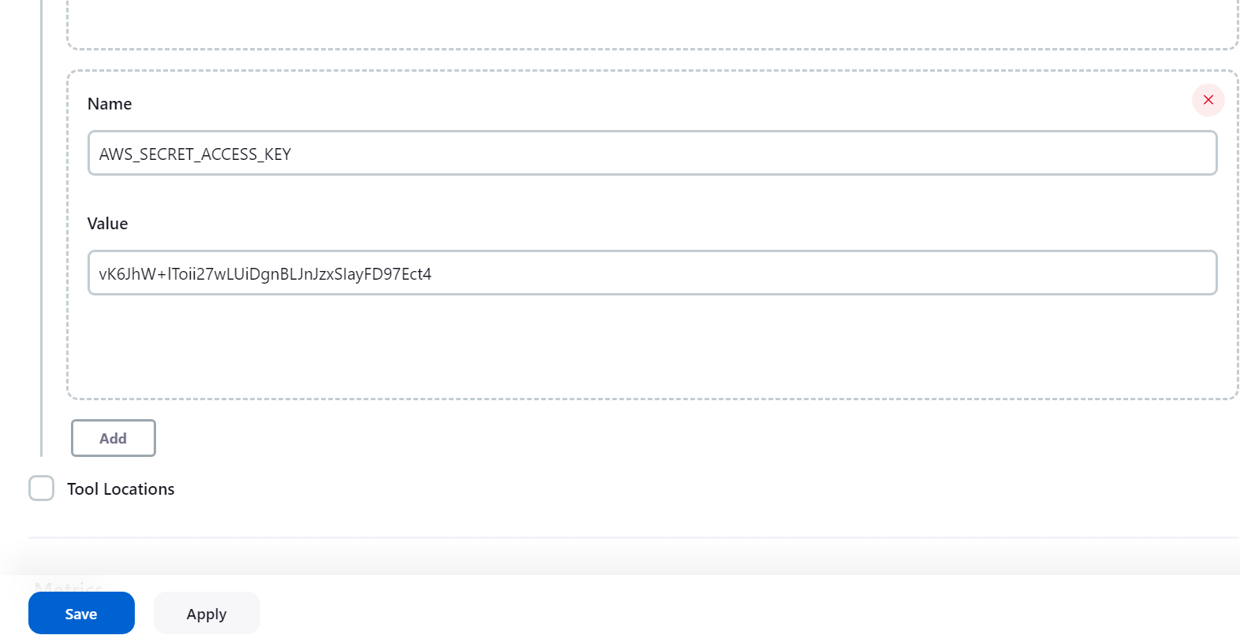

**EXAMPLE:** (I use like this in code)

**[] AWS_ACCESS_KEY_ID="${env.AWS_ACCESS_KEY_ID}"**

**[] AWS_SECRET_ACCESS_KEY="${env.AWS_SECRET_ACCESS_KEY}"**

**----------------------------------------------------------------------------------------**

1. **Code for to push docker image to ECR**

pipeline {

agent any

environment {

AWS_ACCESS_KEY_ID="${env.AWS_ACCESS_KEY_ID}"

AWS_SECRET_ACCESS_KEY="${env.AWS_SECRET_ACCESS_KEY}"

AWS_REGION=('us-east-1')

}

stages {

stage('Cloning Git') {

steps {

git credentialsId: 'PAT', url: 'https://github.com/kanchana08/Dockerfile_python.git'

}

}

stage('Build Docker Image') {

steps {

sh "docker build -t lamda_ply:latest ."

}

}

stage('Publish to ECR') {

steps {

script {

sh "aws ecr get-login-password --region us-east-1 | docker login --username AWS --password-stdin 165271113309.dkr.ecr.us-east-1.amazonaws.com"

sh "docker tag lamda_ply:latest 165271113309.dkr.ecr.us-east-1.amazonaws.com/lamda_ply:latest"

sh "docker push 165271113309.dkr.ecr.us-east-1.amazonaws.com/lamda_ply:latest"

}

}

}

}

}

==========================================

**2)** **Code for to push docker image to ECR** (I put build function in stage('Publish to ECR') )

pipeline {

agent any

environment {

AWS_ACCESS_KEY_ID="${env.AWS_ACCESS_KEY_ID}"

AWS_SECRET_ACCESS_KEY="${env.AWS_SECRET_ACCESS_KEY}"

AWS_REGION=('us-east-1')

}

stages {

stage('Cloning Git') {

steps {

git credentialsId: 'PAT', url: 'https://github.com/kanchana08/Dockerfile_python.git'

}

}

stage('Publish to ECR') {

steps {

script {

sh "aws ecr get-login-password --region us-east-1 | docker login --username AWS --password-stdin 165271113309.dkr.ecr.us-east-1.amazonaws.com"

sh"docker build -t lamda_ply ."

sh "docker tag lamda_ply:latest 165271113309.dkr.ecr.us-east-1.amazonaws.com/lamda_ply:latest"

sh "docker push 165271113309.dkr.ecr.us-east-1.amazonaws.com/lamda_ply:latest"

}

}

}

}

}

**=========================================**

**Code for s3 bucket :**

pipeline{

agent any

environment {

AWS_ACCESS_KEY_ID="${env.AWS_ACCESS_KEY_ID}"

AWS_SECRET_ACCESS_KEY="${env.AWS_SECRET_ACCESS_KEY}"

AWS_REGION=('us-east-1')

}

stages{

stage('exm stage'){

steps {

script{

sh"aws s3 ls"

}

}

}

}

}

====================================================

**Deleted previous latest tag images first and then push new images**

pipeline {

agent any

environment {

AWS_ACCESS_KEY_ID="${env.AWS_ACCESS_KEY_ID}"

AWS_SECRET_ACCESS_KEY="${env.AWS_SECRET_ACCESS_KEY}"

// AWS_REGION=('us-east-1')

AWS_REGION="${env.AWS_DEFAULT_REGION}"

}

stages {

stage('Cloning Git') {

steps {

git credentialsId: 'PAT', url: 'https://github.com/kanchana08/Dockerfile_python.git'

}

}

stage('Build Docker Image') {

steps {

// script {

// dockerImage = docker.build "lamda_ply:latest"

// }

sh "docker build -t lamda_ply:latest ."

}

}

stage('Publish to ECR') {

steps {

script {

sh "aws ecr get-login-password --region us-east-1 | docker login --username AWS --password-stdin 165271113309.dkr.ecr.us-east-1.amazonaws.com"

sh" aws ecr batch-delete-image --repository-name lamda_ply --image-ids imageTag=latest"

//sh" aws ecr batch-delete-image --repository-name lamda_ply --image-ids imageTag=latest"

sh"docker tag lamda_ply:latest 165271113309.dkr.ecr.us-east-1.amazonaws.com/lamda_ply:latest"

sh "docker push 165271113309.dkr.ecr.us-east-1.amazonaws.com/lamda_ply:latest"

}

}

}

}

}